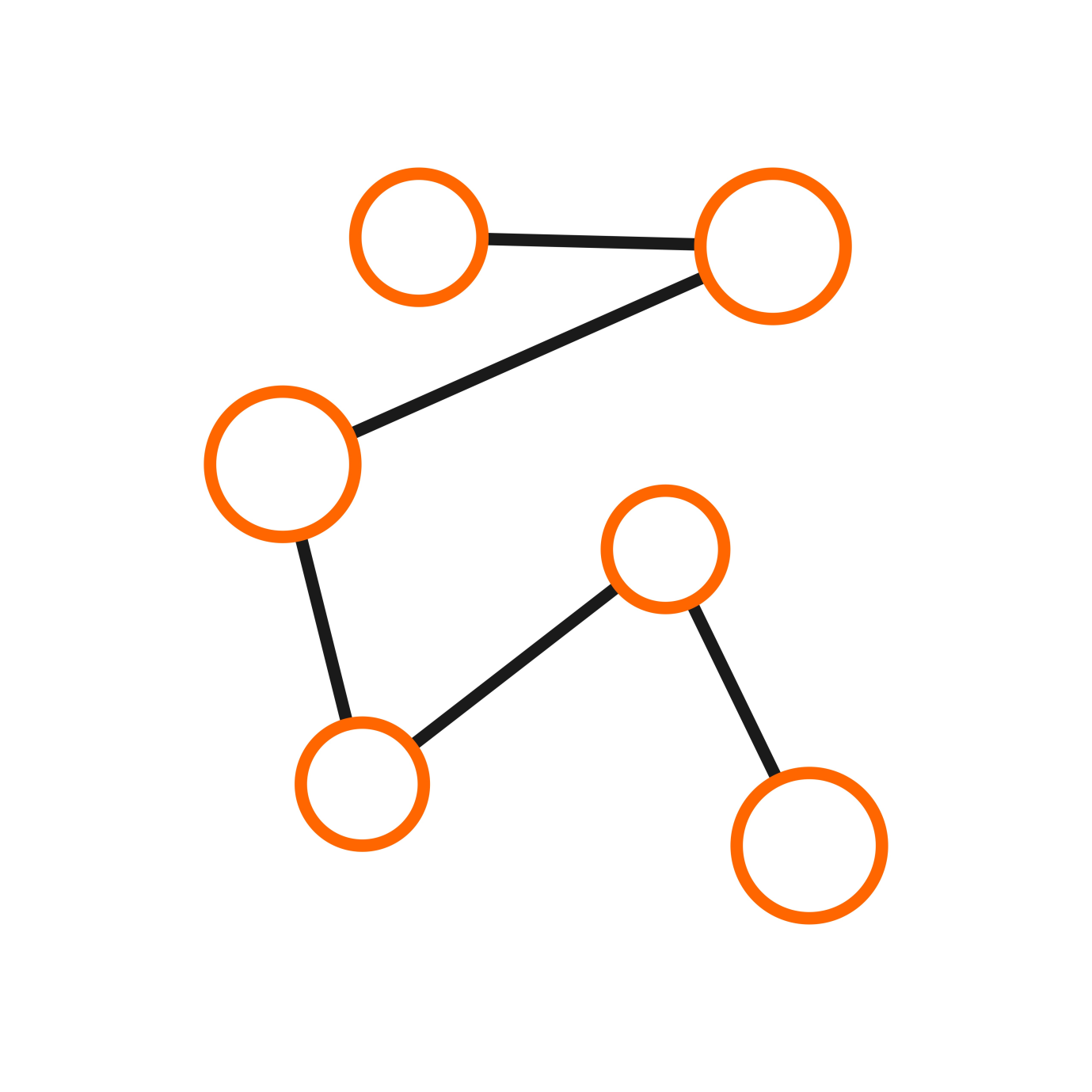

Web Designer & Developer

Programmer.sifatahmed@gmail.com

Jquery

HTML 5

CSS 3

**Secondery School Certificate (2020)**

Mark Ideal High School

“Bangla Lion Computer Training Center” is a computer training center. It is situated in Sreebordi, Sherpur, Mymonshingh, Dhaka, Bangladesh..

“Kakoli Computer and Telicom Center” is a Computer training center. It is situated in Sreebordi, Sherpur, Mymonshingh, Dhaka, Bangladesh..

**Juniour School Certifate (2018)**

Nazrul Academic School

**Worked**

**Development Experriencve**

DataBase

**Design Experience**

www.sifatahmed.ezyro.com

+880 1919-367347

I am Sifat Ahmed, I am a pixel-perfect web developer. I am an experienced and expert in the web development section and working since 2018. Full and fresh hand code is my power. Client satisfaction is my first priority. Work with me and be happy with the result.

Sifat

Ahmed

**Kakoli Computer and Telicom Center**

Seniour Computer Trainer

**Bangla Lion Computer Training Center**

As a trainer of computer operating

**ABOUT ME**

**HOBBIES**

**EDUCATION**

Reading

Node.Js

PHP

C++ (Back-end)

**Primary School Certificate (2015)**

Nazrul Academic School

HandBall

Music

Hiking

JS